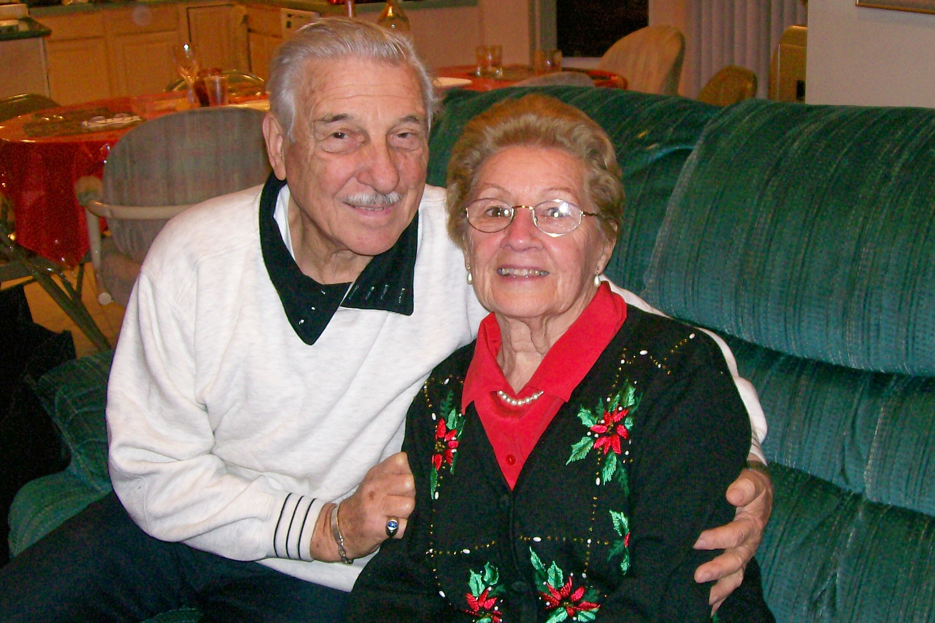

60 years of married bliss!

Ellen & Al La Rocca will be celebrating their 60th wedding anniversary on May 22nd 2008. We know nothing would make them happier than hearing from all the family and friends who’ve touched their lives through the years. If you would send a card and mention a treasured moment, extend special wishes or even include a photo (old or new!) this would bring great joy to two very wonderful people. Thank you for sharing your memories and love with our parents. Sincerely, Joyce & Skip

Ellen & Al La Rocca
11 Devon Rd
Bethpage, NY 11714

Thank you all for your generous responses to the anniversary announcement we sent, our apologies if we missed sending you one!

